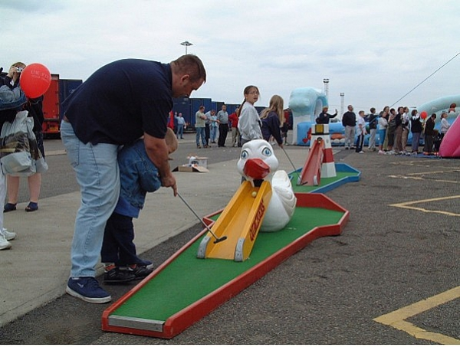

[](http://www.peterjohnson.co.uk/catalogue/crazy-golf-challenge-c-59?catalogue_search_term=crazy%20golf&search=1)

Crazy Golf Challenge Wednesday August 7th • For all the Family

Club together to challenge our nine-hole course of obstacles that offer endless fun and a great way for the youngest to try a brand-new sport and develop their hand-eye co-ordination.